Chapter 5, Solution 36

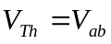
But 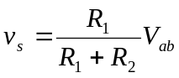. Thus,
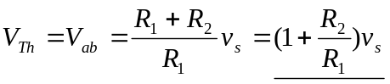
To get R_{Th}, apply a current source I_{o} at terminals a-b as shown below.

v₁
+
v₂ - a

+
R₂
v_{o} i_{o}
R₁
-
b

Since the noninverting terminal is connected to ground, v₁ = v₂ =0, i.e. no current passes through R₁ and consequently R₂ . Thus, v_{o}=0 and

